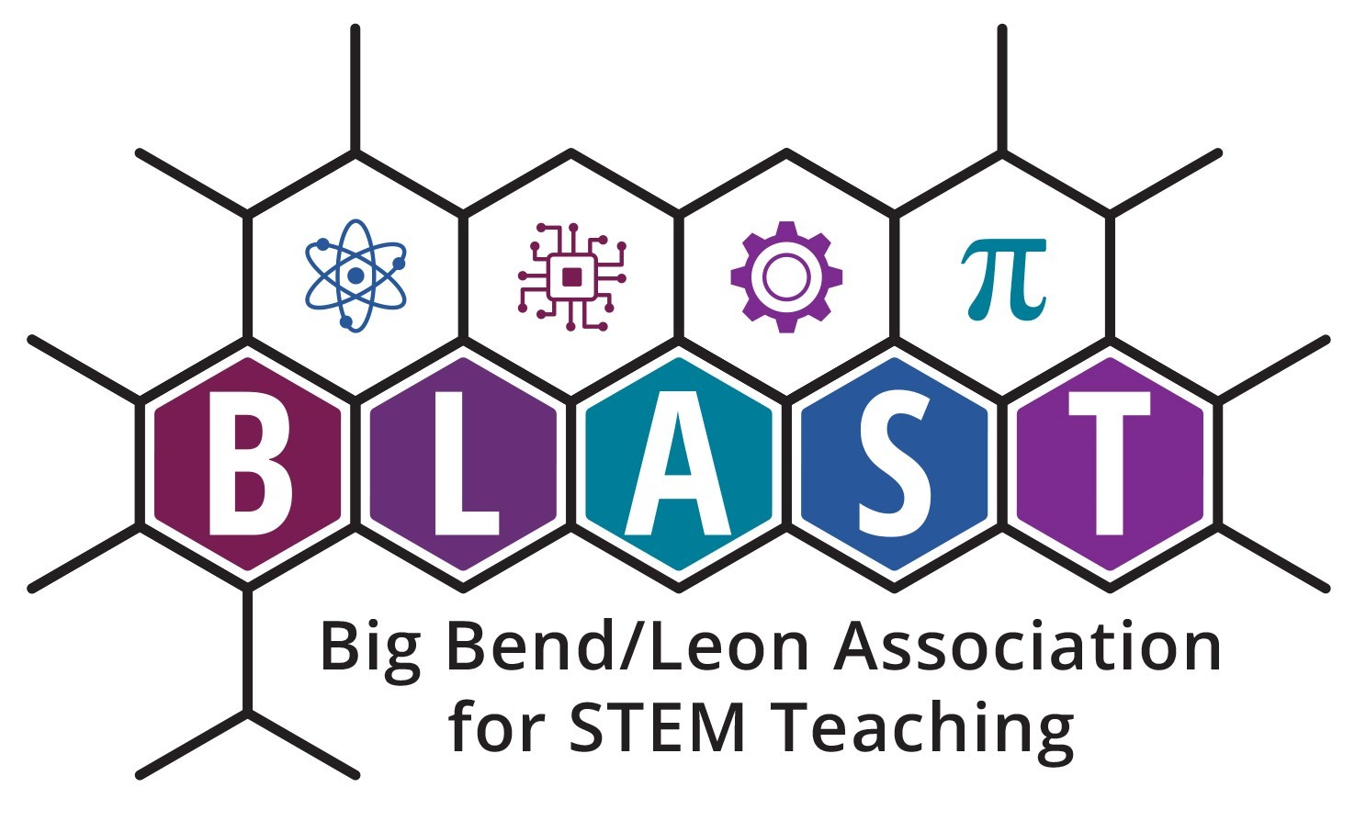

Mission: Big Bend / Leon Association for STEM Teaching (BLAST) is an organization for K–20 STEM educators that supports ongoing education and develops professional learning opportunities with the goal of fostering STEM literacy.

Completed applications must be received by September 15, 2023.

Email questions to: Chris Harvey E-mail: harveyc@leonschools.net

Applicants will be notified of their status when grants are evaluated.

Please have this information ready to enter in the online application linked here.

Applicant Name: ___________________________________ Email: ___________________________________

School Name: ____________________________________________________ Phone: ____________________

School Address: __________________________________________________ Zip: ______________________

Grade Level(s): _____________________________ Subject Area(s): ___________________________________

Title of Project: ________________________________________________________________________________

Number of students who will benefit from this project: __________

Prepare answers for the 4 following items. Please refrain from including information that identifies the teacher, student, and/or school in your answers.

- Describe what you expect students to learn and/or be able to do at the conclusion of the project. Include measurable objectives. (20 points)
- Describe the details of the project, an expected timeline, and examples of what you expect students will do during your project. (30 points)
- Describe the methods you will use to evaluate the learning gains of your students as described in the objectives and student outcomes. (30 points)
- Provide a detailed budget, including an itemized list of materials and costs. (20 points)

Maximum Mini-Grant funding is $250 for teachers.

